# Poster Skeleton

Background

* LHC&CMS
* Deep Learning (CNNs)

Objective & Scope

* Objective: Use a deep learning model to analyze the data from the CMS Open Data portal
* Scope: Production of top quark pair events

Process

* Overview
* Getting data & Creating JSON
* Images Creation
* Classifying images by Transfer Learning technique

Result & Conclusion

# Background

1. LHC & CMS

LHC (The Large Hadron Collider) the world’s largest particle collider, is used to accelerate particles beams and guide the particle’s collision. CMS (Compact Muon Solenoid) is a particle detector, like a cylindrical onion, has different layers to measure different properties of particles.

1. Deep Learning (CNNs)

Deep learning with convolutional neural networks (CNNs) is one of the most widely effective methods in computer vision and speech recognition for past few years, which gives us the probabilities to apply it in particle physics analysis.

# Objective & Scope

1. Objective:

Use deep learning model to analyze the data from the CMS Open Data portal. Specifically, we use the image classification which is an application of CNNs in the context of analysis in experimental High Energy Physics (HEP).

1. Scope:

We focus on the production a pair of quarks top anti-top (ttbar) and discriminate them from other process (background).

* Top quark pair events:
  + Each top quark decays into a W boson and a bottom quark.
  + One of W bosons decays leptonically into a charged lepton, electron or muon, with an associated neutrino.
* Background:
* W + jets events
* Drell-Yan processes

# Process

1. **Overview**

We use Open Data Monte Carlo samples of collisions at LHC from CMS Open Data portal to create images containing information of different physics observables. Then we train convolutional neural network on these images to distinguish the different physics process.

1. **Getting data & Creating JSON**

* **Data Type:** AODSIM root files

Collisions, also known as events, recorded in a HEP experiment by a detector like CMS. Ana these events are described by a set of variables: the momentum of muons, electrons, photons and hadrons produced in the collision of the two accelerated protons, which have been released as Open Data by the CMS collaboration

* **JSON file:** Containing the main information on the physics observables.
* **Flow:** Create link to condition database and download the target index respectively. Generate JSON using a C++ framework based on a template provided by the Open Data group.

1. **Images Creation**

* All the observables are to be represented using a canvas of dimension 224×224 pixels. Each particle or physics object is represented as a circumference with a radius proportional to its energy.
* The **momentum direction**, coordinates the **pseudorapidity η** and the **azimuthal angle φ**
* **Color:** different type of particles and physics objects

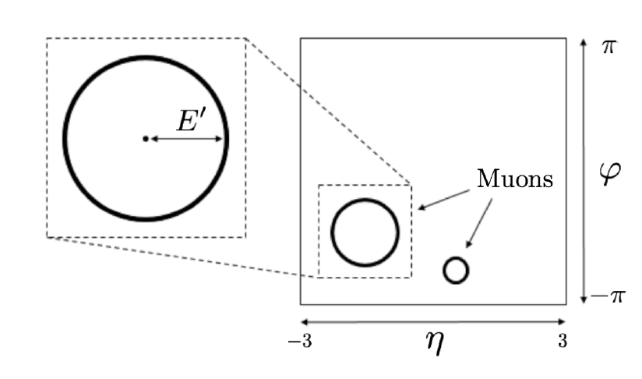

* In our experiment:

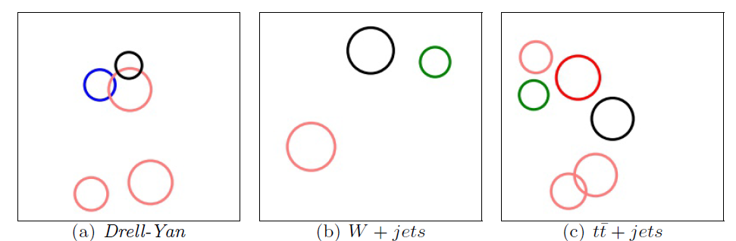

**Circumferences**: Leptons and Jets

**Radius**: proportional to transverse momentum

Scale: Pt’ = C * ln (pt) (C ~ 10.5)

**Color:**

* blue for **the electrons**
* green for **the muons**
* light red for **non-B-tagged jets**
* dark red for **B-tagged jets**
* **Black** for **missing transverse energy**

1. **Classifying images by Transfer Learning technique**